

TECVICO Corp (Technological Virtual Collaboration Corporation) is an international company founded by Dr. Mohammadreza Salmanpour in Vancouver BC, Canada in 2020. It aims to facilitate the connection between industry and researcher/expert. The headquarter of TECVICO is located in Canada, and its researchers are virtually collaborating from different countries such as Portugal, Iran, Canada, Germany, India, and other.

Our Vision is to become one of the largest platforms for offering. We will do our best to achieve this goal.

**You can contact and follow us in:**

[](https://twitter.com/tecvico/)

Human Resource: [HR@mail.tecvico.com](mailto:HR@mail.tecvico.com)

Public Relations: [PR@mail.tecvico.com](mailto:PR@mail.tecvico.com)[](https://www.instagram.com/tecvico/)[](https://www.linkedin.com/company/tecvico)

Advertisement: [ADV@mail.tecvico.com](mailto:ADV@mail.tecvico.com)

Chief Executive Officer: [CEO@mail.tecvico.com](mailto:CEO@mail.tecvico.com)[](http://t.me/tecvico)[](https://facebook.com/tecvico)

Chief Technology Officer: [CTO@mail.tecvico.com](mailto:CTO@mail.tecvico.com)

Research Director: [RD@mail.tecvico.com](mailto:RD@mail.tecvico.com)[](https://tecvico-projects.slack.com/join/shared_invite/zt-n480n53n-N0Z8AjWuF7eoxo1d0eqb6w#/shared-invite/email)

Industry Director: [ID@mail.tecvico.com](mailto:ID@mail.tecvico.com)

Competition Director: [CD@mail.tecvico.com](mailto:CD@mail.tecvico.com)

In this guideline, we first aim at explaining the sections of the site, then explaining on how everybody can apply for projects in accordance with each role.

Before login, on main page of the site, you can observe following bottoms as follows:

1. Home

1.1. Suggestion Box

1.2. Contact us

1.2.1. FAQ

1.2.2. Q & A

1. Members
2. Projects
3. News
4. Archive

5.1. Videos

5.2. Documents

1. Join Us

6.1. Individual

6.2. Company

1. Login

7.1. Forgot Password



This is the main bottoms of the site. You can see it on top of the screen before login as follows:

# **1. Home:**

To have access to the home page, just click on Home on the top-left corner of the screen.

In this page, you can find a brief introduction about the company, quick user guide, latest news, suggestion box and company’s contact information.



## Let’s see some important parts of Home page:

# **1.1. Suggestion Box**:

In the suggestion box you can write your feedback, so don't miss it.

You can find it at the bottom of the Home page. After entering your Full Name, Email and your Feedback message, press submit, and we’ll check it soon!

Sample:

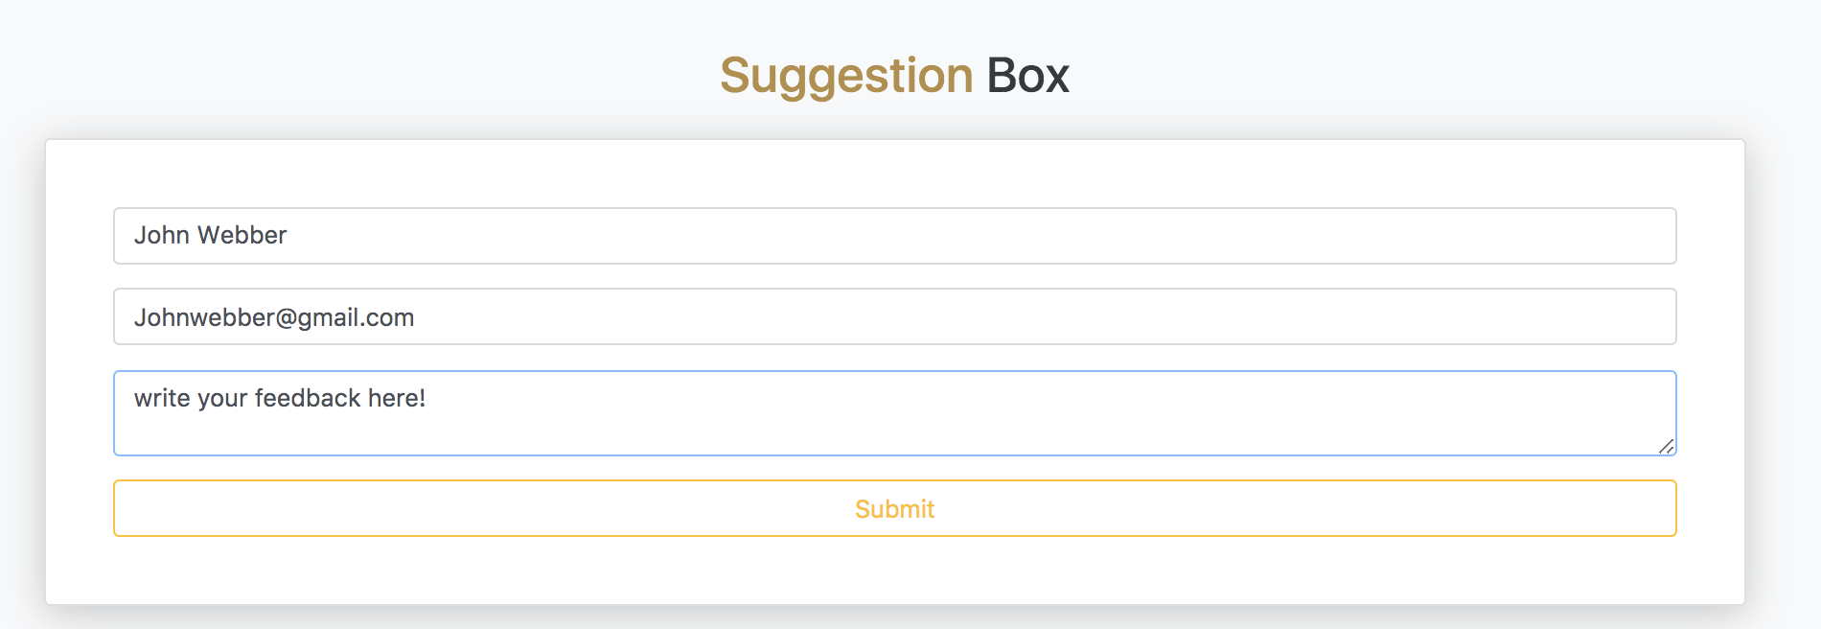

## **1.2. Contact us:**

If you aim to contact us, just scroll down at the bottom of the Home Page and you can find contact ways.



# **1.2.1. FAQ:**

In FAQ section, you can find some general questions about TECVICO accompanied with its answer.

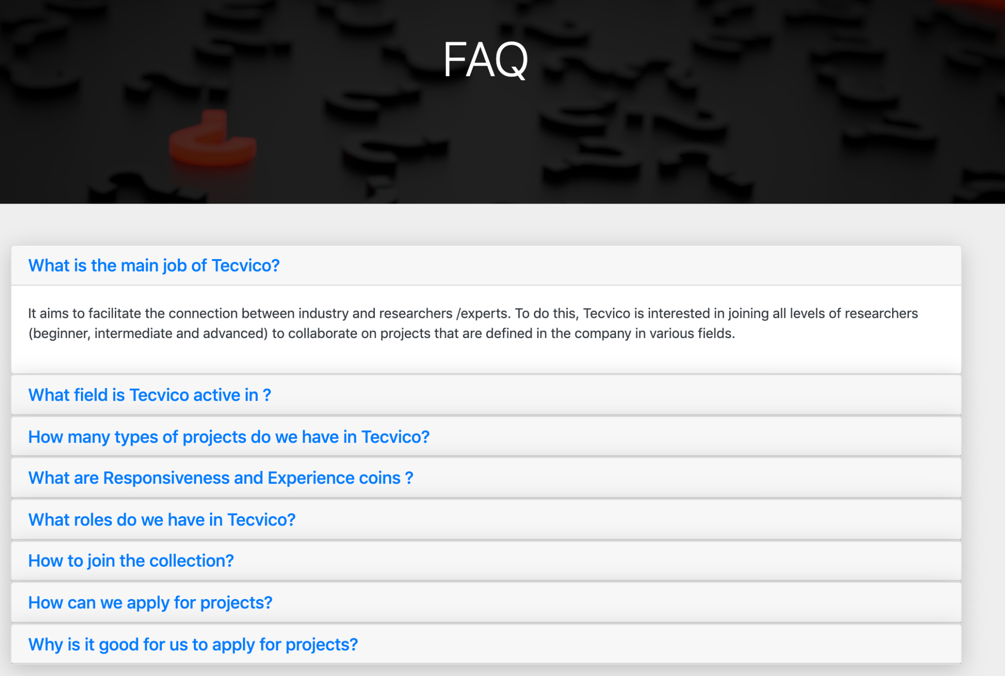

# **1.2.2. Q & A:**

If you have any questions, you can ask us in this section.

By clicking on each question, you can see the whole question and given answers so far.

Do not hesitate to answer the questions you know.



Ask your question by clicking on post one!. Write your name, email(optional) and your question then submit it. Hope you get your answer well.

# **2. Members:**

In Members section, you can find information about the company's main members accompanied with their brief information.



# **3.Projects:**

# 

We have three types of project: Research, Competition and Industry.

In this section, you can find list of projects accompanied with their information.

To see the projects, first choose the type of project:

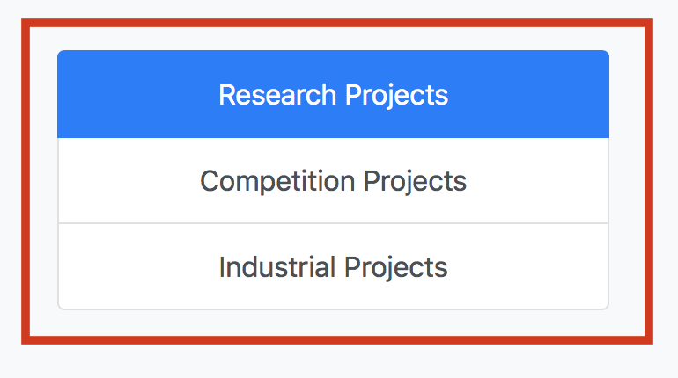

Projects are shown in 3 positions as follows:

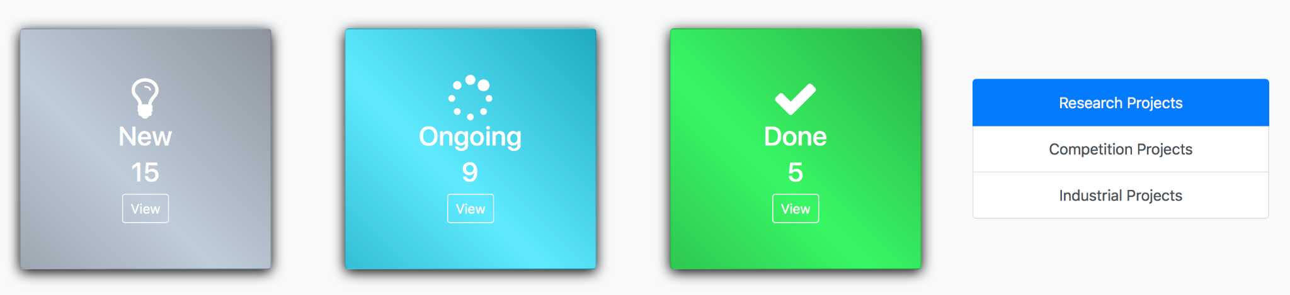

If you click the view button in each state, you can see the title of the projects and their start date.

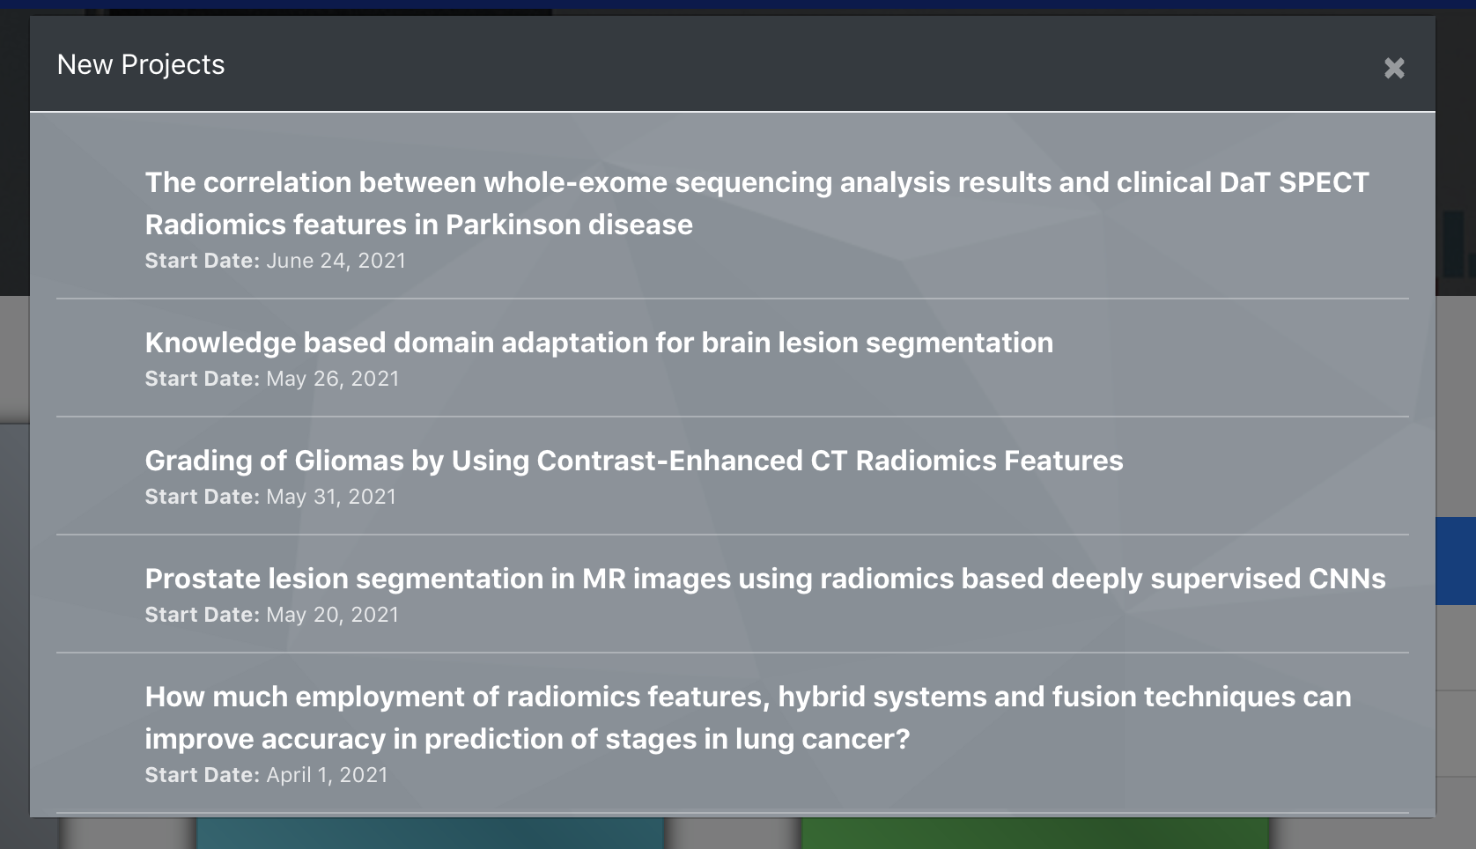

In order to get access to new projects and applying for them, you must go to **Join Us** and register yourself in the site.

# **4. News:**

# 

Here, you can see the news of the company.

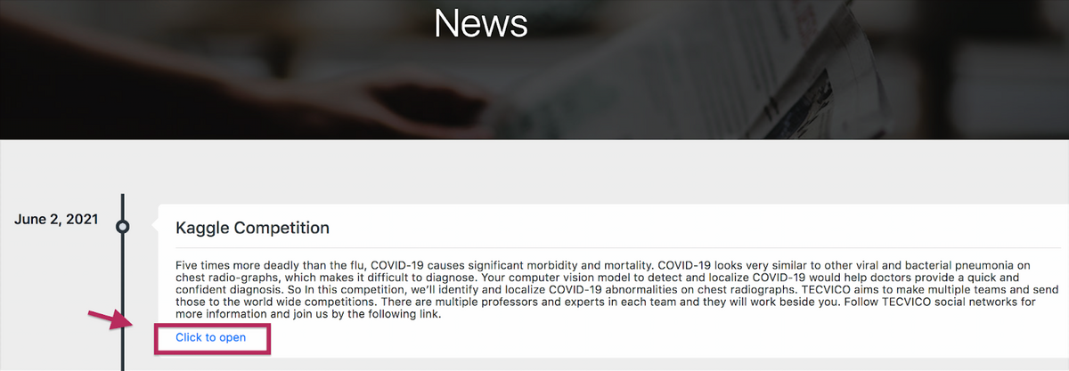

*Read more information about the news by clicking on “Click to open “.

# **5. Archive:**

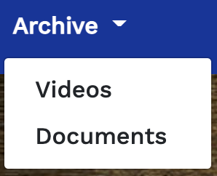

In this section, you can find a collection of our educational contents.

They are sorted in two categories: Videos, Documents.

Click on each category to have access to the content.

## **5.1. Videos**

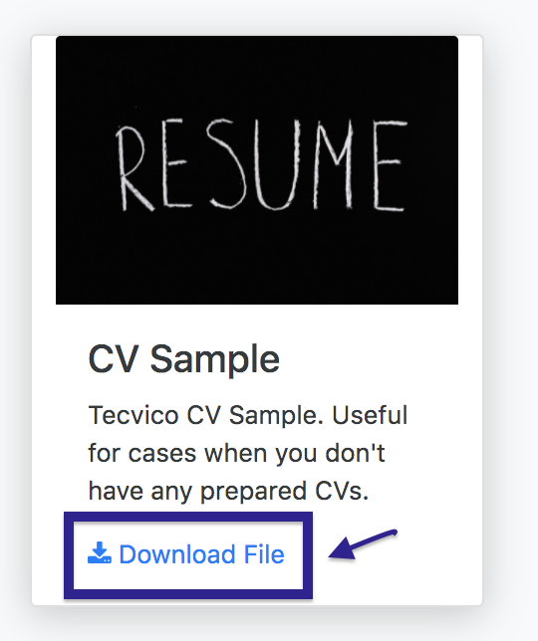

## **5.2. Documents**

In this section, you can have access to the

documents, download and use them.

# **6. Join Us**

At the top-right corner of the Home page, you can join us via clicking on **Join Us.**



## **6.1. Individual**

## 

If you are signing up as an individual person,

please select **Individual** and fill out

the form as follows:

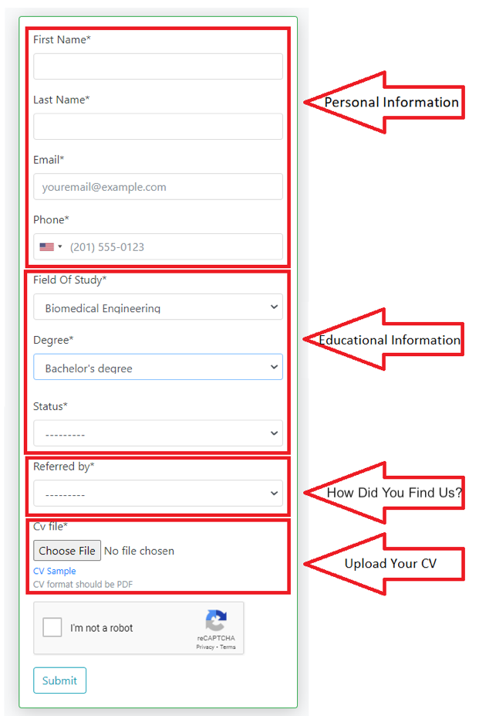

## **6.2. Company**

If you are signing up as a company, you should

select **Company** and fill out the form as

follows:

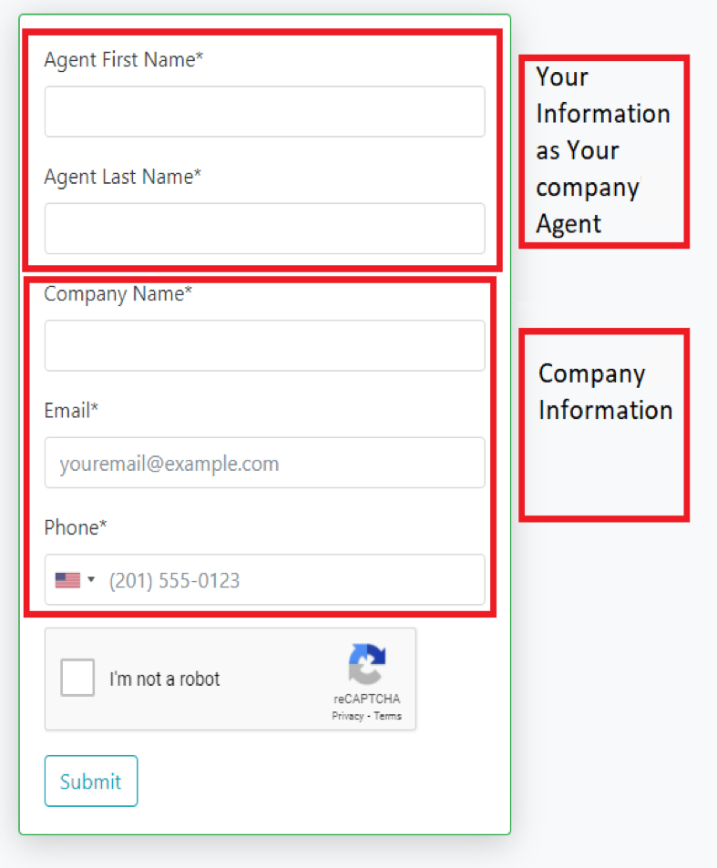

# 

# **7. Login**

At the top-right corner of the Home page, you can go to your profile via **Login** button.



Insert your username (your Email you used to register) and password (If you are you entering for the first time, the company will email you a temporary password after registering and you should change it when entering) the as follows.

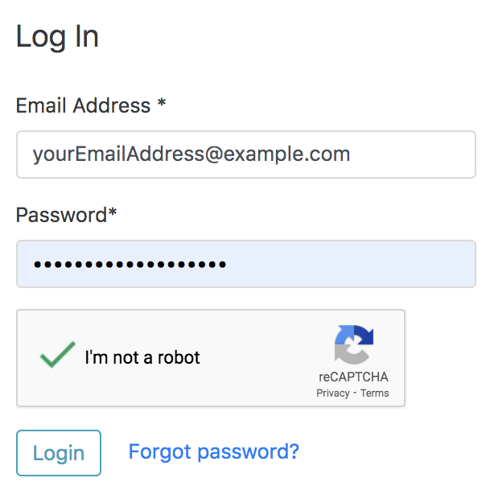

## **7.1. Forgot Password**

## 

If you forgot your password, click on insert your Email address you used for registration as follows:

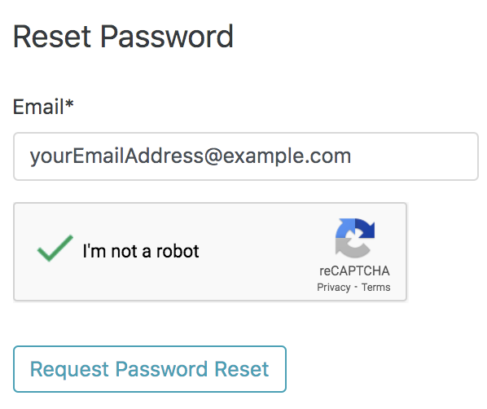

After you click on  , an email should be sent with instructions to reset your password.

Just go to the following page, select and choose a new password with requested requirements as follows.

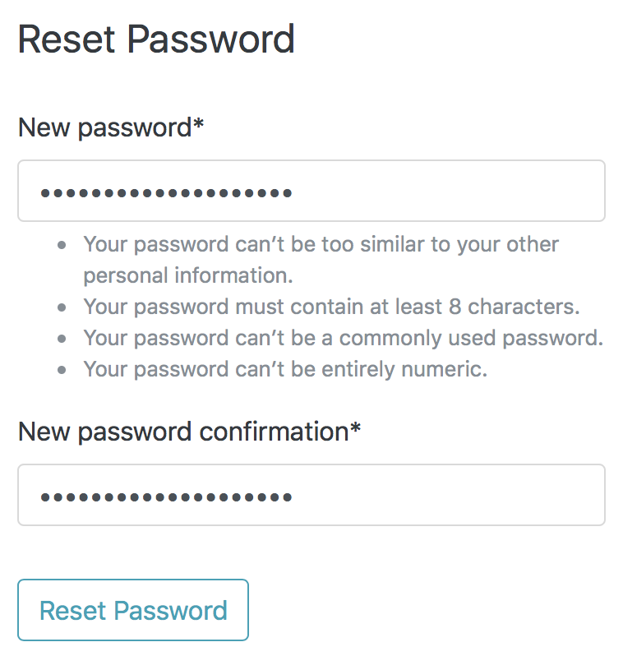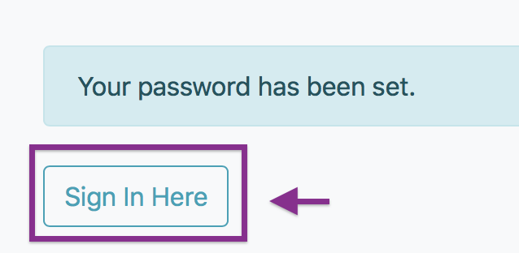

After clicking on Reset Password, your new

password will set and you can sign in by it.

* **After joining TECVICO, you can participate in projects. Initially, Your role will be given you based on your resume, education, and interview score.**

**(Main Supervisor, Mentor, Member and Lerner)**

* **The description of these roles, how to apply for the project based on your role and other items will be comprehensively explained as follows.**

# **Project roles** :

### [Supervisor](https://docs.google.com/document/d/1H9udNYg_Uh_QRcV22NkADTra_OIBlkdI/edit" \l "heading=h.2s8eyo1)

1. [Mentor](https://docs.google.com/document/d/1fZ5ROUDPvC5hthH0j2diA-IXdP7YvQ3D/edit)
2. [Member & Learner](https://docs.google.com/document/d/1GTcqIyPrInAPBbONX34WldcnTW_XKM1U/edit)